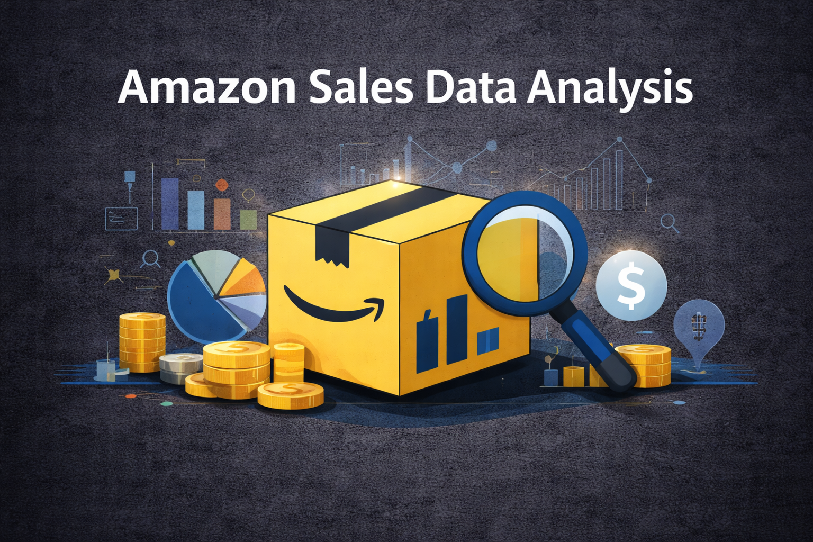
S

Amazon SQL Project
Business Analysis Documentation

Overview
This project focuses on analysing Amazon sales data using SQL to understand overall business performance. The main goal is to uncover sales patterns, identify top-performing products and categories, analyse customer behaviour, and evaluate seller and delivery performance.
By organizing raw transactional data into a well-structured relational database and applying SQL queries, this project provides insights into revenue trends, customer purchasing habits, product demand, returns, and seller efficiency.
The insights generated from this analysis help Amazon-style e-commerce businesses make data-driven decisions to improve sales, optimize inventory, reduce returns, and enhance customer satisfaction.

Problem Statement
Amazon handles a massive volume of sales, product, customer, and shipping data every day. However, raw transactional data alone does not provide meaningful insights unless it is properly structured and analysed.

Key Challenges:
- Sales, product, customer, and shipping data exist across multiple tables
- Difficult to track total revenue and monthly trends without aggregation
- Hard to identify top-performing products, categories, and sellers
- No direct visibility into return patterns and delivery performance
- Customer behaviour and order value trends are not immediately obvious
Without structured SQL analysis, business teams cannot easily evaluate performance or make strategic decisions.

What’s Happening?
- Orders are stored across orders and order items tables
- Product and category information is separated into different tables
- Customer, seller, and shipping details are stored independently
- Raw data does not directly show revenue, rankings, or trends
- Manual analysis would be slow and error-prone
This makes it difficult to answer key business questions such as:
- Which products generate the most revenue?
- Which categories perform best?
- Which sellers contribute the most to sales?
- Where are returns happening frequently?

Solution Goal
- The goal of this project is to solve these problems using SQL-based data analysis.
- Clean and organize sales data into a relational structure
- Use SQL queries to calculate revenue and performance metrics
- Identify top-selling products and high-revenue categories
- Analyse customer behaviour and average order value
- Track delivery and return patterns
- Enable business-friendly insights for decision-making

Data Description
Project Title: Amazon Sales Data Analysis
Data source:Kaggle
Dataset Size: ~1,500+ rows
Data Types Used:
- VARCHAR (names, states, categories)
- NUMERIC / FLOAT (prices, revenue, quantity)
- DATE (order dates, return dates)

Key Tables and Fields

Customers
- Customer id, first name, last name, state

Orders
- Order id, customer id, seller id, order date

Order Items
- Order item id, order id, product id, quantity, price per unit

Products
- Product id, product name, category id

Category
- Category id, Category name

Sellers
- Seller id, Seller name

Shipping
- Shipping id, order id, delivery status, return date

Payments
. payment id, order id, payment date, payment status
Inventory
. inventory id, Product id, Stock, Warehouse id , last stock date
Data Cleaning Steps
To ensure accurate analysis, the following data cleaning steps were applied:
- Removed missing or incomplete records
- Ensured consistent text formatting (trimmed spaces, standardized case)
- Verified numeric fields such as quantity and price
- Ensured correct date formats for order and return dates
- Validated foreign key relationships between tables
- Normalized data into structured tables to avoid duplication

SQL Approach
- Used JOINs to connect multiple tables
- Applied aggregate functions (SUM, COUNT, AVG)
- Used DATE_TRUNC for monthly analysis
- Implemented WINDOW FUNCTIONS (RANK) for product ranking
- Used GROUP BY for category and seller analysis
- Handled divide-by-zero cases using NULLIF

Snow flake schema
Dimension tables are split into multiple related tables
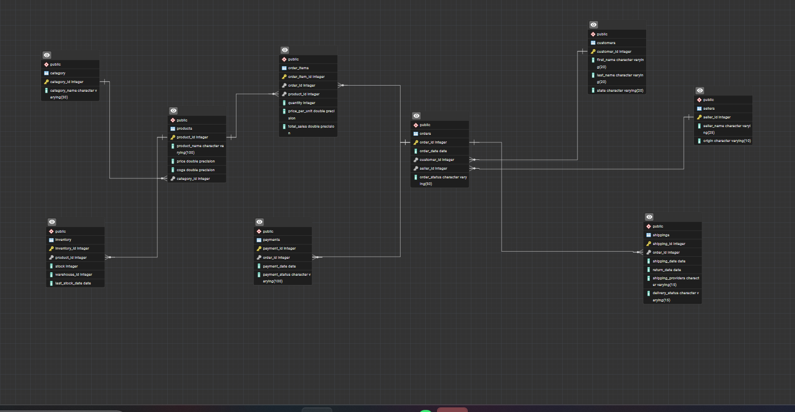

Revenue & Sales Performance Analysis

1.Total Revenue
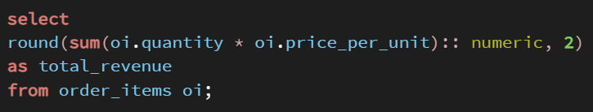
Syntax:

Data output:

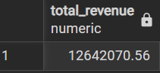

Insight:
Calculates the total income generated from all orders.

What this tells us:
Shows overall business performance and growth potential.

2. Monthly Sales Trend

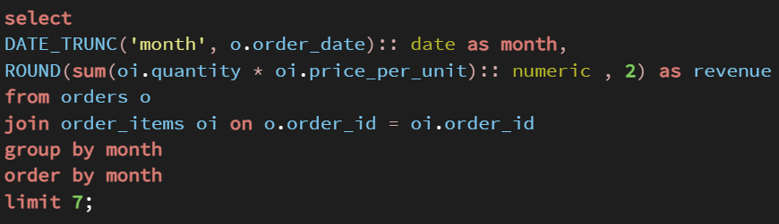
Syntax:

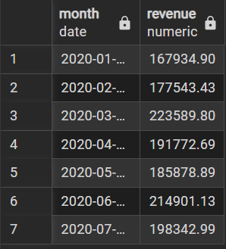
Data output:

Insight:
Shows revenue generated month-by-month
Identifies seasonal trends
Helps compare business growth over time
Useful for forecasting future sales
What this tells us:
The monthly sales trend reveals how revenue fluctuates over time, helping identify growth patterns, seasonal demand, and overall business stability.

3.Average Order Value

Syntax:
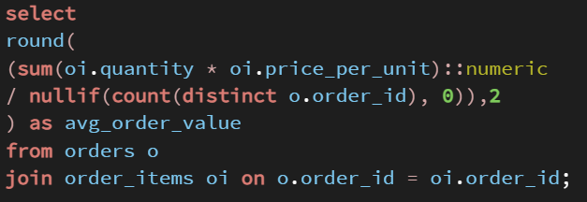

Data output:
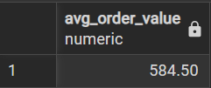

Insight:
Measures customer spending behaviour
Higher AOV indicates better upselling or pricing strategy

What this tells us:
Average Order Value indicates how much revenue each order generates on average, providing insight into customer spending patterns and the effectiveness of pricing and upselling strategies.

Product Performance Analysis

1.Top 10 Best-Selling Products

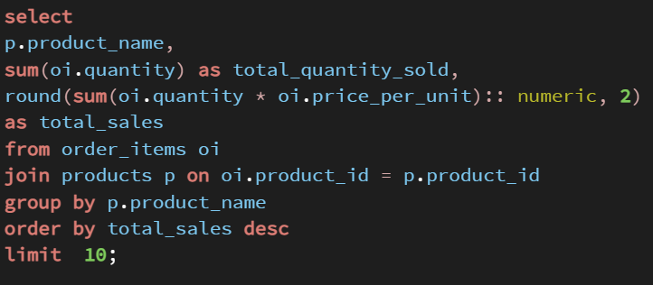
Syntax:

Data output:
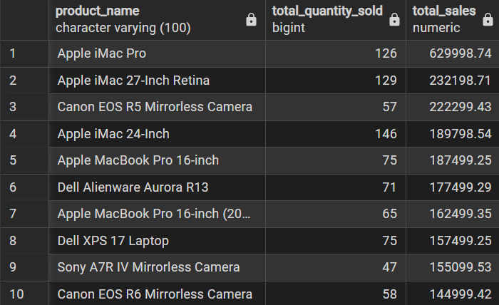

Insight:
This analysis shows which products bring the most revenue to the business. It tells us that a few high-value products generate a large share of total sales, even if they are not sold in very high quantities. By identifying these top-selling products, the business can focus on better stock planning, targeted promotions, and maintaining availability of items that have the biggest impact on revenue.
What this tells us:
This analysis identifies the top 10 best-selling products based on total revenue, not just quantity.
Total quantity sold → customer demand
Total sales value → revenue contribution
2. Rank Products by Revenue

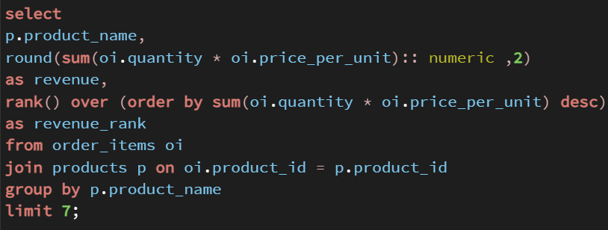
Syntax:

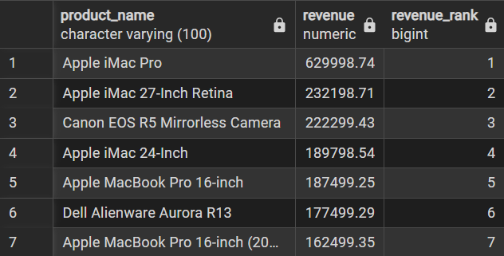
Data output:

Insight:
This query ranks products based on the total revenue they generate, making it easy to compare product performance. It helps identify which products contribute the most to overall sales and which ones have a lower impact. This ranking supports better business decisions related to inventory planning, pricing, and promotional focus.
What this tells us:
Shows the relative position of each product based on revenue, clearly highlighting the top-performing and lower-performing products in the dataset.

3. Products with Highest Returns

Syntax:
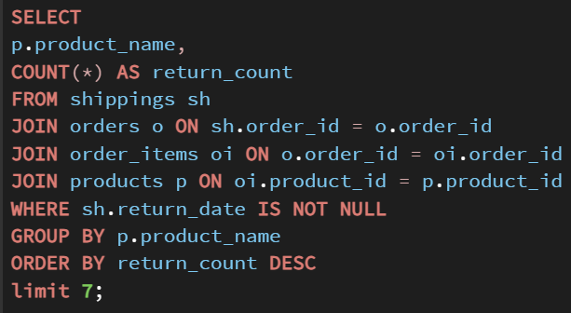

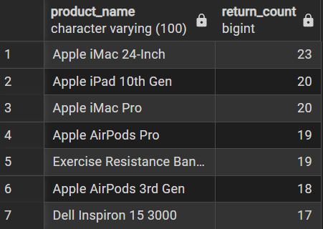
Data output:

Insight:
This analysis identifies products that are returned most frequently by customers. A high return count can indicate issues such as product defects, unmet customer expectations, or delivery-related problems. Understanding these return patterns helps the business improve product quality, descriptions, and after-sales processes.

What this tells us:
Shows which products have the highest number of returns, highlighting items that may require attention to reduce return rates and improve customer satisfaction.
Category-Level Analysis

1.Revenue by Category

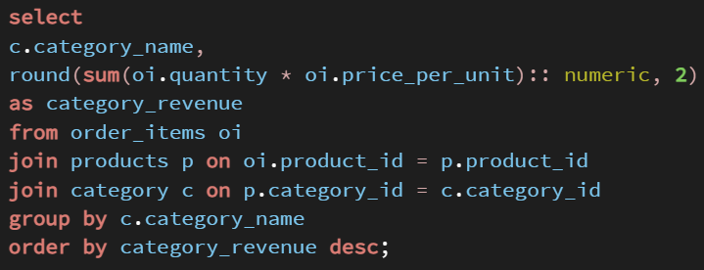
Syntax:

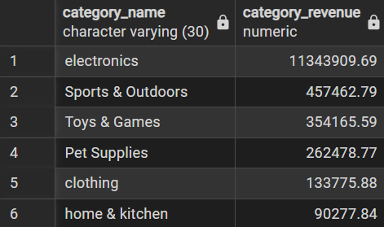
Data output:

Insight:
This analysis shows how total revenue is distributed across different product categories. It helps identify which categories contribute the most to overall sales, with Electronics clearly generating the highest revenue. This insight supports better category-level decisions such as inventory planning, marketing focus, and budget allocation.
What this tells us:
Shows the revenue performance of each category, making it easy to compare top-performing and low-performing categories in the business.

2.Orders Returned by Category

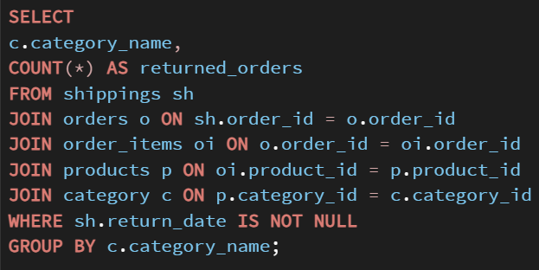
Syntax:

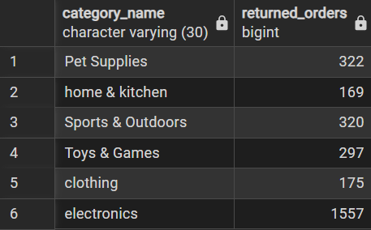
Data output:

Insight:
This analysis shows which product categories experience the highest number of returned orders. A high return count in certain categories may indicate issues such as product quality concerns, incorrect product descriptions, sizing problems, or customer expectation gaps. Identifying these categories helps the business focus on reducing returns and improving customer satisfaction.
What this tells us
Shows the number of orders returned in each category, highlighting categories that require attention to improve product quality, delivery, or customer experience.

3.Best Product in Each Category

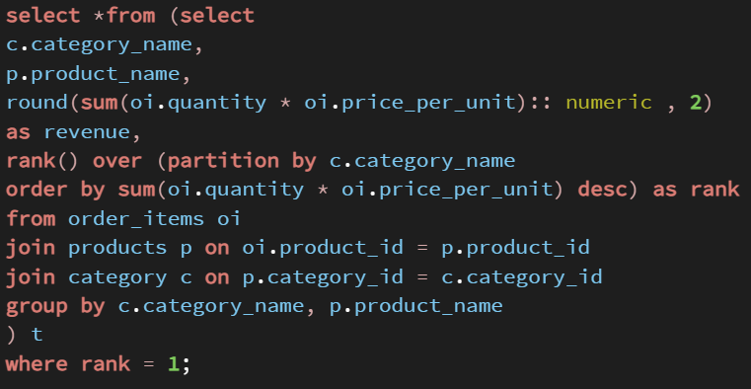
Syntax:

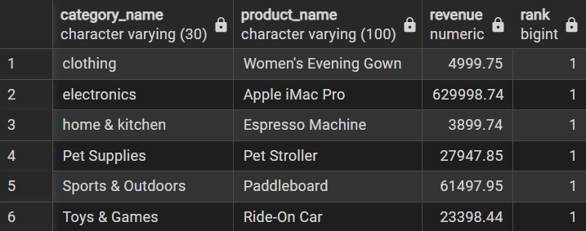
Data output:

Insight:
This analysis identifies the top revenue-generating product within each category. It helps understand which specific product drives the highest sales in its category, allowing the business to focus on promoting, stocking, and supporting these key products.
What this tells us:
Shows the best-performing product in each category based on revenue, clearly highlighting the products that contribute most to category-level sales.

Order & Delivery Analysis

1.Delivered vs Returned Orders
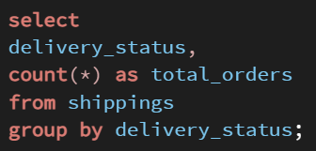
Syntax:

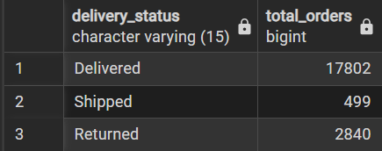
Data output:

Insight:
This analysis compares the number of orders that were delivered, shipped, and returned. It helps evaluate the overall efficiency of the order delivery process, while also highlighting the volume of returns that may impact customer satisfaction and operational costs.

What this tells us
Shows how orders are distributed across different delivery statuses, indicating how many orders were successfully delivered versus those still in transit or returned.

Seller Performance Analysis

1.Revenue by Seller
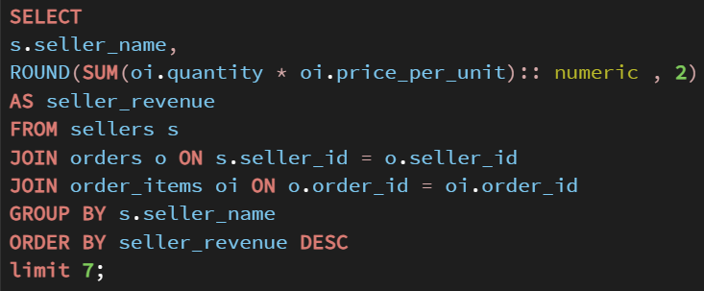
Syntax:

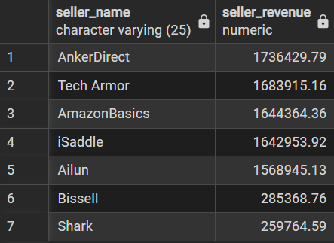
Data output:

Insight:
This analysis shows how total revenue is distributed among different sellers. It helps identify top-performing sellers who contribute the most to overall business revenue, highlighting their importance to the platform’s success. This insight can be used to design seller incentives, partnerships, and performance improvement strategies.

What this tells us:
Shows the revenue generated by each seller, making it easy to compare seller performance and identify high- and low-revenue contributors.

2. Seller Order Count
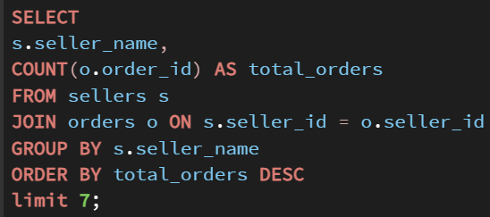
Syntax:

Data output:
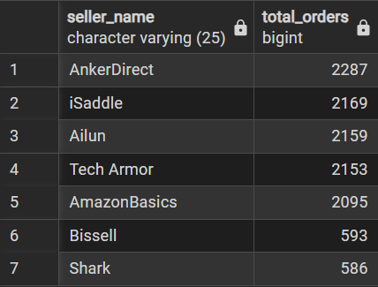

Insight:
This analysis shows how many orders are associated with each seller, helping measure seller activity and order volume. Sellers with higher order counts contribute more transactions to the platform and play an important role in overall sales operations.
What this tells us:
Shows the total number of orders linked to each seller, making it easy to compare seller activity levels across the platform.

Customer Analysis

1.State with Most Customers
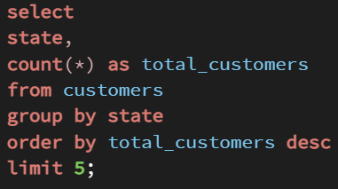
Syntax:

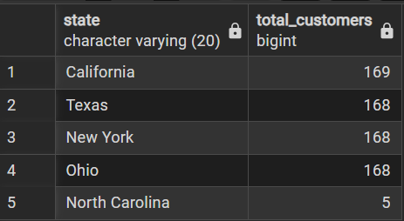
Data output:

Insight:
This analysis shows how customers are distributed across different states. It helps identify key geographic regions where the customer base is strongest, with states like California, Texas, and New York having the highest number of customers. This insight supports regional marketing, sales expansion, and resource planning decisions.
What this tells us:
Shows the states with the highest number of customers, highlighting regions that contribute most to the customer base.

2. Customers with Most Orders
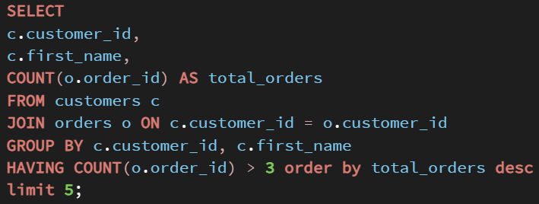
Syntax:

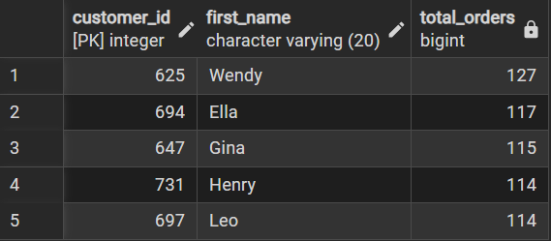
Data output:

Insight:
This analysis identifies customers who place orders frequently, highlighting the most loyal and high-engagement customers. These customers contribute significantly to repeat sales and play an important role in consistent revenue generation. Understanding this group helps the business design loyalty programs and personalized offers.

What this tells us:
Shows customers with the highest number of orders, clearly identifying repeat buyers in the customer base.

Overall Insights and Recommendations

1. Seller Performance
Insight:
- Sales performance varies significantly among sellers on the platform.
- A small group of sellers generates a high number of orders and revenue, while others show lower activity.
- This indicates differences in product demand, pricing strategy, and seller efficiency.
Recommendations:
- Strengthen partnerships with top-performing sellers through incentives and better visibility.
- Analyse successful sellers to identify best practices and apply them to improve performance of lower-activity sellers.

2. Customer Distribution
Insight:
- Customers are concentrated in specific states such as California, Texas, and New York.
- These regions contribute a large share of the customer base and sales activity.
- Other states show lower customer engagement.
Recommendations:
- Focus marketing campaigns and faster delivery options in high-demand states.
- Improve outreach and offers in low-demand regions to increase customer engagement.

3. Customer Loyalty

Insight:
- A small group of customers places a high number of repeat orders.
- These loyal customers contribute significantly to consistent revenue.
- Most customers place fewer orders.

Recommendations:
- Introduce loyalty programs, personalized offers, and exclusive discounts for repeat customers.
- Encourage occasional buyers to become repeat customers through targeted promotions.

4. Seller & Customer Activity Gaps
Insight:
- Some sellers and customers show low activity levels.
- This may be due to pricing, product availability, or delivery-related issues.
Recommendations:
- Review pricing, inventory levels, and delivery performance for low-activity sellers.
- Improve availability and service quality to balance overall platform performance.

Overall Business Performance

Insight:
- The analysis shows that overall revenue is driven by a combination of high-performing products, sellers, and repeat customers.
- Sales are concentrated in specific categories, sellers, and geographic regions.
- Returns and uneven seller activity indicate areas where operational improvements are needed.
Recommendations:
- Focus on high-impact products, categories, and sellers by ensuring strong inventory availability and platform visibility.
- Reduce return rates by improving product quality, descriptions, and delivery handling.
- Use customer and seller insights to make data-driven decisions that improve efficiency, customer satisfaction, and long-term business growth.

